1st Research Area
Learning from Sparse, Skewed, or Irregular Data

Overall Goal
This research focuses on developing machine learning models that remain robust and accurate when faced with the inherent "noise" of financial data. The goal is to move beyond standard algorithms to architectures that can interpret long gaps between events, generalize from minimal examples, and handle extreme imbalances where critical events (like fraud) represent less than 1% of the total dataset. By reconstructing sparse data into dense representations, this research aims to improve prediction stability across banking and insurance verticals.

1.1 Sparse Event Sequences

This research area addresses the challenge of modeling financial events that occur at irregular intervals with long gaps of inactivity, such as infrequent transactions or rare fraud signals. The objective is to treat these gaps not as missing data, but as an informative signal of behavioral patterns

Model Used:
Transformer-based sequence encoder adapted for sparse events.
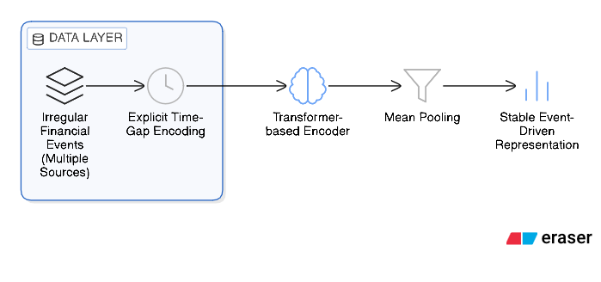

Working Principle:
Transactions are converted into sequences with numerical and categorical embeddings, along with positional (time) encoding. The transformer’s self-attention mechanism learns relationships between past and present transactions, allowing the model to predict future behavior and detect deviations such as fraud or abnormal activity.

1.2 Few-shot / Zero-shot Learning for Risk Prediction

The goal is to design models that generalize from very few labeled examples, specifically for emerging fraud types or new customer segments where historical data is scarce. This approach shifts the focus from direct classification to learning a robust, foundational understanding of behavior

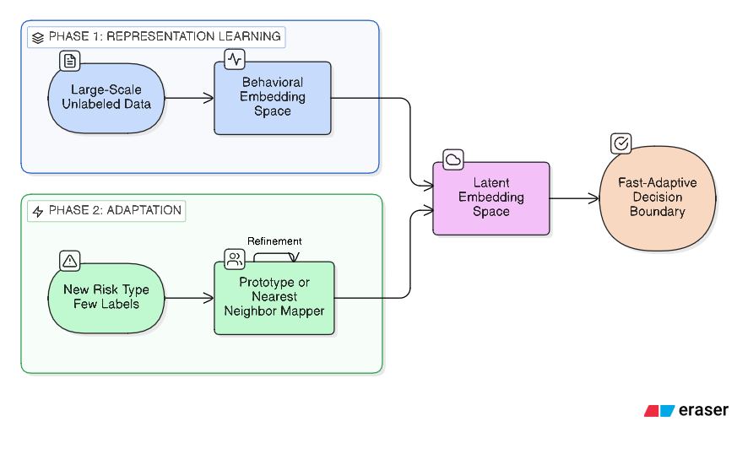
Model Used:
Prototypical Networks and Meta-learning frameworks

Working Principle:
The system first learns a high-dimensional behavioral embedding space using large-scale unlabeled data. When a new risk type is identified, the model uses metric-based generalization (prototypes) to map the new sample into the existing space, enabling fast adaptation without requiring a full model retrain

1.3 Handling Missing Features in Multimodal Financial Data

This area focuses on building robust models that can operate effectively when key attributes—such as KYC documents, demographics, or behavioral logs—are missing, noisy, or incomplete. The objective is to handle structured missingness without relying on naive imputation strategies

Model Used:
Multimodal Transformer with Cross-Modal Attention and Modality Dropout
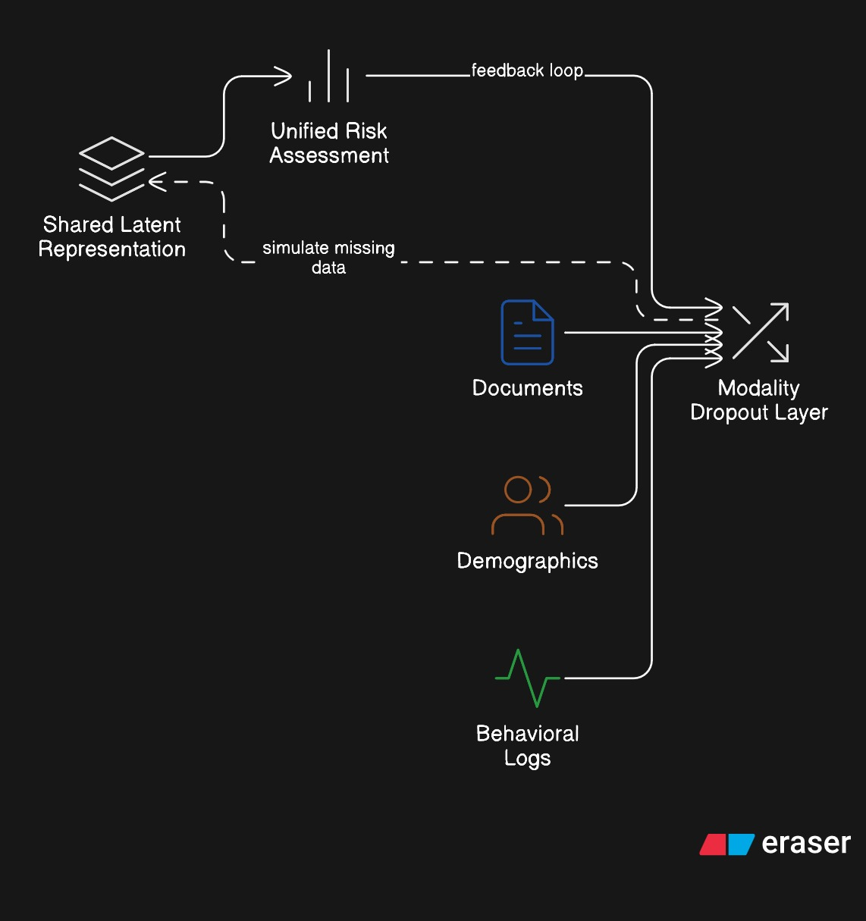

Working Principle:
Each data modality (text, image, temporal) is processed through specialized encoders. During training, "modality dropout" is used to simulate missing inputs, forcing the model to learn shared latent representations that allow it to produce a unified risk assessment even when certain data channels are entirely absent

1.4 Generative Reconstruction of Sparse Datasets

This research utilizes generative AI to stabilize noisy and unstable representations derived from sparse financial records. Rather than synthesizing raw data, the goal is to "clean" the model's internal understanding of a customer's history

Model Used:
Variational Autoencoder (VAE) applied to learned embeddings.
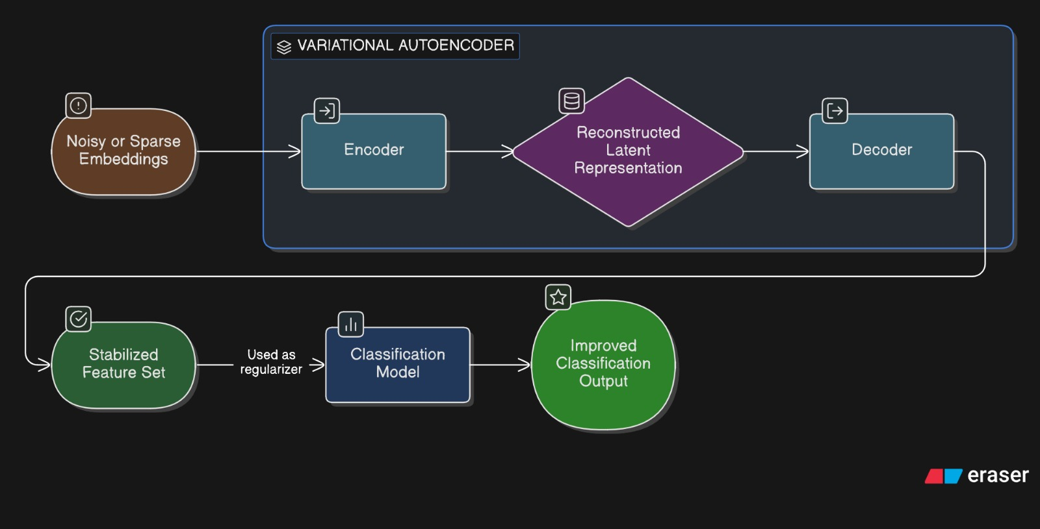
Working Principle:
The model maps sparse, irregular transaction logs into a latent embedding space. A VAE then performs generative reconstruction on these embeddings, using the reconstruction process as a regularizer to reduce noise and variance, resulting in a dense and robust representation for downstream prediction tasks.

1.5 Learning under Extreme Class Imbalance

This area investigates methods for handling datasets where positive cases—such as fraud, non-performing assets (NPA), or claims rejections—represent less than 1% of the total data. The goal is to avoid the pitfalls of accuracy-based training on skewed distributions
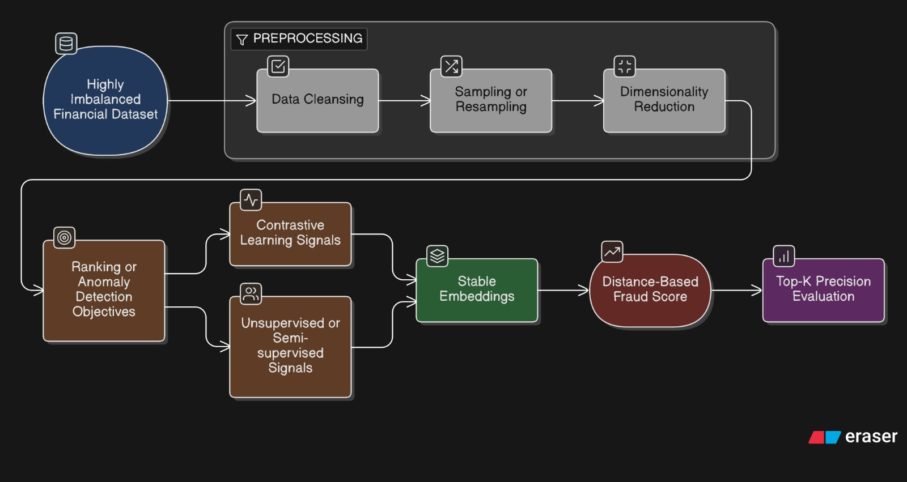

Model Used:
Contrastive Learning (Triplet Loss) and Ranking-based objectives.

Working Principle:
The model is trained to organize data in the latent space by "pushing" rare fraud cases far away from the cluster of normal behavior using a ranking objective. A fraud score is then calculated as the mathematical distance from a "normalcy centroid," allowing the system to identify anomalies based on structural deviations rather than simple binary labels

